International American
Karate Kyokushin Championships

KWF USA Little Lions Cup
June 29, 2019

Bulletin No. 1

1. INTRODUCTION

The Kyokushin World Federation USA in cooperation with the European Kyokushin Federation and the Kyokushin World Federation have the pleasure to invite you to the International American Karate Kyokushin Championships in the city of Chicago, Illinois, USA.
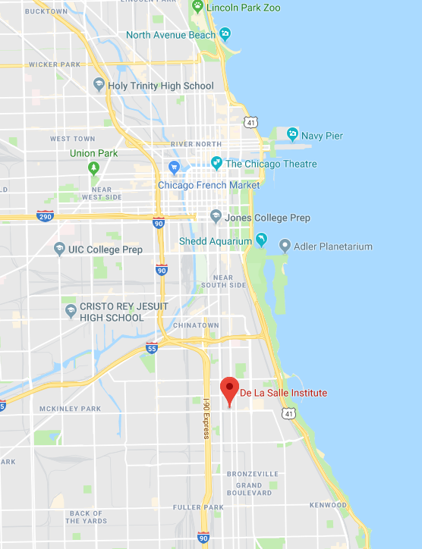
The event will take place at the De LaSalle Institute Sport Hall located at 3434 S Michigan Ave, Chicago, IL, USA.

Time zones.
Chicago is located in a Central Time Zone in the United States which is one hour behind New York City and 2 hours ahead of Los Angeles: When it is noon (12pm). in Chicago it is 1pm (13.00) in New York and 10am in Los Angeles, 6pm (18.00) in London, 7pm (19.00) in European Union and 2am in Tokyo.

2: GENERAL HOTEL

Best Western Grant Park Hotel
Address: 1100 S Michigan Ave, Chicago, IL phone +1(312) 922-2900

4th of July (Thursday after the tournament) is a national holiday in the United States also known as Independence Day and many people across the country take time off during this week.
Chicago downtown area / lake waterfront hosts spectacular fireworks show at 9pm on July 4.

Room category | Number of people | Room per night  (6/27-7/1) | Room per night  (7/1-7/4)
One King size bed | 2 adults + 1 child | $146 | $107
2 Double beds | Up to 4 people | $158 | $107

Prices shown above include sales tax of approximately 17% added to the price of the room during checkout.

Hotel room booking.
Hotel rooms can be booked directly from hotel’s website by going to the website created by hotel for our event. Keep in mind room average room prices shown on the website **DO NOT INCLUDE** 17% tax which is added at the end of the payment and also prices will depend on the duration of stay and will include price structure listed above typically shown during final checkout.
Listed above prices are valid until May 27 and are refundable if cancellation is made at less than 24 hours before arrival date.

Room reservation link
https://www.bestwestern.com/en_US/book/hotelrooms.14120.html?groupId=5G5SV1R9
Phone Reservations.
Guest should contact our hotel directly at 1-800-472-6875 or 312-922-2900 to make their reservations. Guests must mention KWF - USA, in order to receive this special rate.

There is a limited number of rooms available so make sure you make your reservations early.

Feel free to contact us at KWF USA if you have any additional questions about hotel rooms.
You can always make you own reservation by using expedia.com and book other hotels if needed.
Keep in mind expedia offers lower prices to customers who create an account.
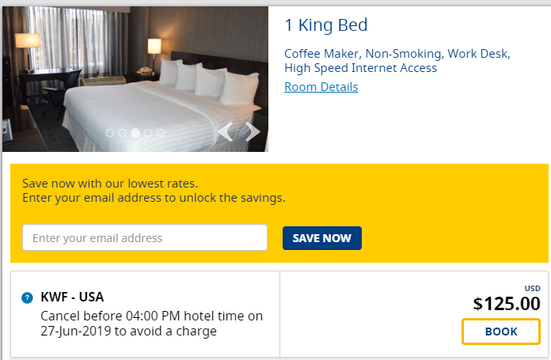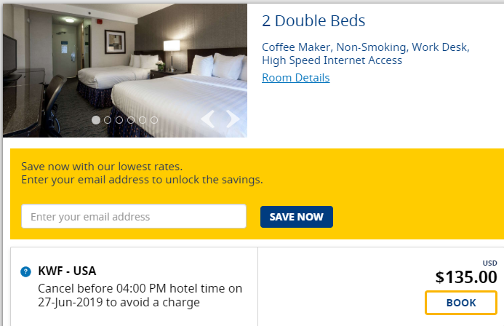

Information about additional hotels will be available soon if needed.

Travel.

Arriving at Chicago O’Hare International Airport you can travel to Chicago center / downtown directly by city subway. City of Chicago Transit information including detailed maps and fares can be found at www.transitchicago.com .

You have to arrive to the hotel no later than Friday June 28 early afternoon or on Thursday June 27.

3. COMPETITION CATEGORIES
The Championship will take place in kumite and kata divided into categories of women and men.
PLEASE LOOK AT ANNEX KUMITE RULES AND KATA RULES.

  - . KUMITE CATEGORIES AND KATA

CHAMPIONSHIPS
12 - 13 YEARS OLD GIRLS.
12 - 13 YEARS OLD BOYS.
14 - 15 YEARS OLD GIRLS.
14 - 15 YEARS OLD BOYS:
JUNIOR GIRLS (16 - 17 YEARS OLD)
JUNIOR BOYS (16 - 17 YEARS OLD)
SENIOR WOMEN (+18 YEARS OLD)
SENIOR MEN (+ 18 YEARS OLD)
OLDBOY MEN (+ 35 YEARS OLD)
LITTLE LIONS CUP
6 – 7 YEARS OLD BOYS AND GIRLS / KATA ONLY
8 – 9 YEARS OLD BOYS AND GIRLS / KATA AND KUMITE
10 – 11 YEARS OLD BOYS AND GIRLS / KATA AND KUMITE
PLEASE REVIEW ADDITIONAL REGISTRATION CATEGORIES AND RULES FOR KUMITE AND KATA.

Attention:
Detailed KWF rules regarding Kumite and Kata can be found in 3 attachments: International Championship Officials, Rules of Kyokushin Kata Competition and Categories Children and Juniors.

3.2. OBLIGATORY PROTECTIONS

PLEASE REFER TO KUMITE RULES FOR CHILDREN AND ADULTS DOCUMENTS.

3.3. PROTECTORS
Below are shown the athletic supporters (protectors) required during the Championship, approved by the KWF.
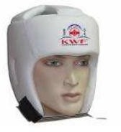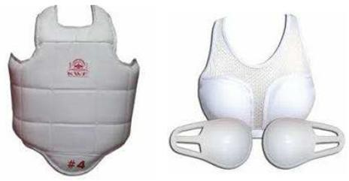

KWF USA MAY ALLOW other types of athletic supporters with other logo types only if they have the same level of protection and keep similar aesthetic to the ones branded for KWF, and they have to be approved by the Main Judge of the Championships.

3.4. DURATION OF THE MATCHES

PLEASE LOOK AT ANNEX KUMITE RULES FOR ADULTS AND CHILDREN.

If there are too many participants at the Championship, and preliminary matches have to be done with obligatory decision, it will be communicated before the Championship start.

3.5. KATAS TO BE DONE.

PLEASE REFER TO ANNEX KATA RULES.

The competition will be divided into two rounds.
Four competitors of each k a t a category with the highest scores will pass to the Finals.

4. GENERAL RULES

Observe carefully and select the correct weight-categories, the Judging Team can expel participants if their weight is not the same as stated in the Registration Form.

The Judging Team can modify categories if there are not enough participants.
Important: Every participant must identify him/herself with Passport or ID-card.

Only official Registration Forms undersigned by Country Representative will be accepted.
The deadline for sending in the forms is May 17, 2019.

5. REGISTRATION

Send your Registration Form t o t h e G e n e r a l S e c r e t a r y a n d t o t h e Organizer.
Email addresses are: general.secretary@europeankyokushin.org
kwfusa2019@gmail.com
The weight in and the checking will be done Friday June 28, 2019 at the Grant Park Hotel.
All the competitors, referees and officials must come together at the same time as a group and country.

6. VERIFICATION
This verification will be followed by members of the Judging Team from the KWF USA and Kyokushin World Federation leadership team.

Registration fee per fighter is $50 for kumite and $30 for kata, and $65 for kumite and kata.
Tournament registration fees have to be paid before arrival via PayPal.
Payments can be made via Facebook KWF USA page by donating directly to KWF USA and stating names of people covered by any given donation.

More payment options including Paypal payment option via www.kwfusa.com will be provided soon.

On the weight-check- in you must be prepared to give the following documents:
    - Parents Agreement (only for competitors under 18 years old).
    - Fighter Waiver Form (you have to fill in and sign the document during the weigh).
    - ID or Passport (to check the nationality and age).
    - Doctors certificate (only for kumite competitors).
    - Must pay the participation fee.
    - Each competitor must have a personal insurance for any accident that may occur at the competitions.
    - All the KWF members must present their KWF passport if not must buy a new one.

7. REFEREE MEETING

A meeting including referees, judges and coaches will take place at Grant Park hotel on Friday June 28, 2019. The exact time will be announced later.

8. SAYONARA PARTY
On Saturday night there will be a Sayonara Party for everyone. We hope that you will join the party.
The cost is $25 per person. You can purchase tickets on Friday during registration.

9. ADDITIONAL INFORMATION
More information will be provided in Bulletin No. 2.

We hope to see you in Chicago soon!
Osu!

Kyokushin World Federation USA
Shihan Leslaw Samitowski
+1(773)988-4050
kwfusa2019@gmail.com

